CARLSONS FISH OIL

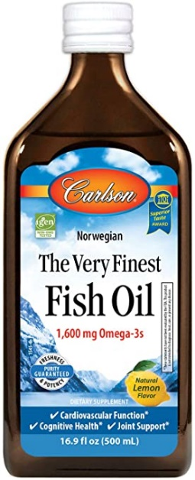
Carlson's fish oil liquid is so good; it's called Carlson The Very Finest Fish Oil. Carlson's lemon-flavored fish oil nutrition supplement is available in the 500 mL size from All Star Health. Each 5 mL serving of pharmaceutical-grade The Very Finest Fish Oil by Carlson contains 1.6 grams of Omega-3 fatty acids and over 800mg of EPA and 500mg of DHA. That's a much higher concentration of good-for-you ingredients than other fish oils with only 100mg to 200mg of EPA and DHA per serving. This high-potency fish oil supplement is also economically priced, just like all our other premium supplements at AllStarHealth.com.
DHA and EPA are the reasons fish oil is good for human health, which is why the high levels of each in Carlson's fish oil liquid makes this nutrition supplement one of our best sellers. Higher-potency fish oils also are more easily absorbed and used by your body, according to studies. Those studies find that lower-grade fish oils are more likely to be burned up as energy or excreted as waste.
The superior-quality fish oil in Carlson's fish oil liquid supplement comes from the cold ocean waters off Norway. This supplement also is bottled in Norway for maximum freshness. You'll like the natural lemon taste. Each serving is one teaspoonful. If you don't want to take as-is, pour it over salads or mix this zesty tasting fish oil product with your favorite foods. This is a premium, healthful product you won't want to keep all to yourself. It's an excellent gift for health-conscious friends, team members, coaches and personal trainers.
What is there to say about Carlson The Very Finest Fish Oil? Well, after reviewing other products on the market it’s safe to say that it really is the finest fish oil. Seriously! Each 5 mL serving of The Very Finest Fish Oil contains 1.6 grams of omega-3 fatty acids and over 800mg of EPA and 500mg of DHA. Yep, you read that right. And that’s in each serving. Most other fish oil supplements contain a mere 100-200mg doses of EPA and DHA per serving while some of the “high potency” fish oil supplements may contain around 300mg of these key omega-3’s. But Carlson’s The Very Finest Fish Oil lives up to its name and redefines high potency pharmaceutical grade fish oil.
To stress to you just how concentrated The Very Finest Fish Oil really is, each 200mL bottle contains 100 servings of the above-mentioned doses. That’s 32 grams of EPA and 20 grams of DHA per bottle. And you can't beat the price. When looking at fish oil supplements, it’s all about the EPA and DHA content. Research supports that the majority of benefits seen from fish oil supplementation come from EPA and DHA, so you better make sure you fish oil supplement is ultra-rich in both.
Studies have shown that the higher potency fish oils absorb more effectively and are better utilized by your body while lower grade fish oils are more likely to be burned up as energy or even worse—excreted as waste. So when you go to pick out a premium grade fish oil supplement, do your research and look at three things: How much EPA and DHA are in each serving? How much EPA and DHA are in the entire bottle? How much does it cost? Carlson’s The Very Finest Fish Oil scores the absolute highest marks when asked each of those three vital questions, and we figure the great taste is just a bonus.

