CBD by FOURTH POWER LABS
Fourth Power Labs' product formulations are developed by Ph.D. scientists and contain a unique cannabinoid blend, rich in CBD and CBG, complemented by a proprietary blend of terpenes that greatly enhance therapeutic benefits.
See how Fourth Power Labs is different.
- Premium, broad spectrum hemp extract always delivers a standardized 8:1 ratio of CBD to CBG and other minor cannabinoids that are THC Free, providing confidence and consistency in every dose.
- The most comprehensive testing program in the industry backed by Eurofins, the only U.S. laboratory to partner with the FDA in method development for testing of cannabinoids, serving as FDA’s outsourcing laboratory for their own testing needs for CBD-based products.
- Commitment to exclusive distribution through Medical Professionals protecting your patient relationship and profits, whether your patients order in-store or online.
Choose from a variety of product forms and dosages to support wellness regimens.
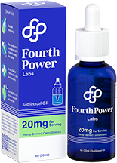
Sublingual Oil
Preferred by nine out of ten consumers in an independent blind taste test. Available in three strengths; 300mg, 600mg and 1200mg
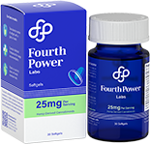

Softgels
An alternate solution to sublingual oil while delivering the same benefits.
Available in two strengths; 450mg, 750mg
Deep Tissue Roll-On
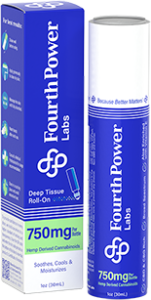
Long-lasting relief to problem areas, anytime.
Available in 750mg

