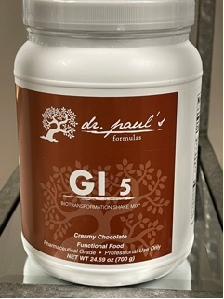
GI 5 Biotransformation Shake Mix (Chocolate and Vanilla)
• Supports Improved Body Composition
• Supports Immune Function by Providing Immunoglobulins and Other Immune Factors
• Supports Healthy Cytokine Production
• Supports Intestinal Health
• Supports Detoxification
GI 5 represents an innovative approach to biotransformation for individuals whose health is constantly challenged. This all-natural, fructose-free formula includes ingredients that promote overall gastrointestinal health and support detoxification mechanisms and cytokine balance in the body. i5 features patented and proprietary ingredients, including 21 g of VegaPro™, a non-GMO, vegetable-based protein, as well as IgG 2000 CWP™, OncoPLEX™ (glucoraphanin), and arabinogalactan, a prebiotic. Practitioners have reported best results when GI 5 is combined with a modified elimination diet.
Directions: Blend, shake, or briskly stir 2 level scoops (45 g) into 8-12 oz chilled water and consume one to two times daily, or as directed by your healthcare practitioner. Adjust amount of water to desired sweetness and thickness.

